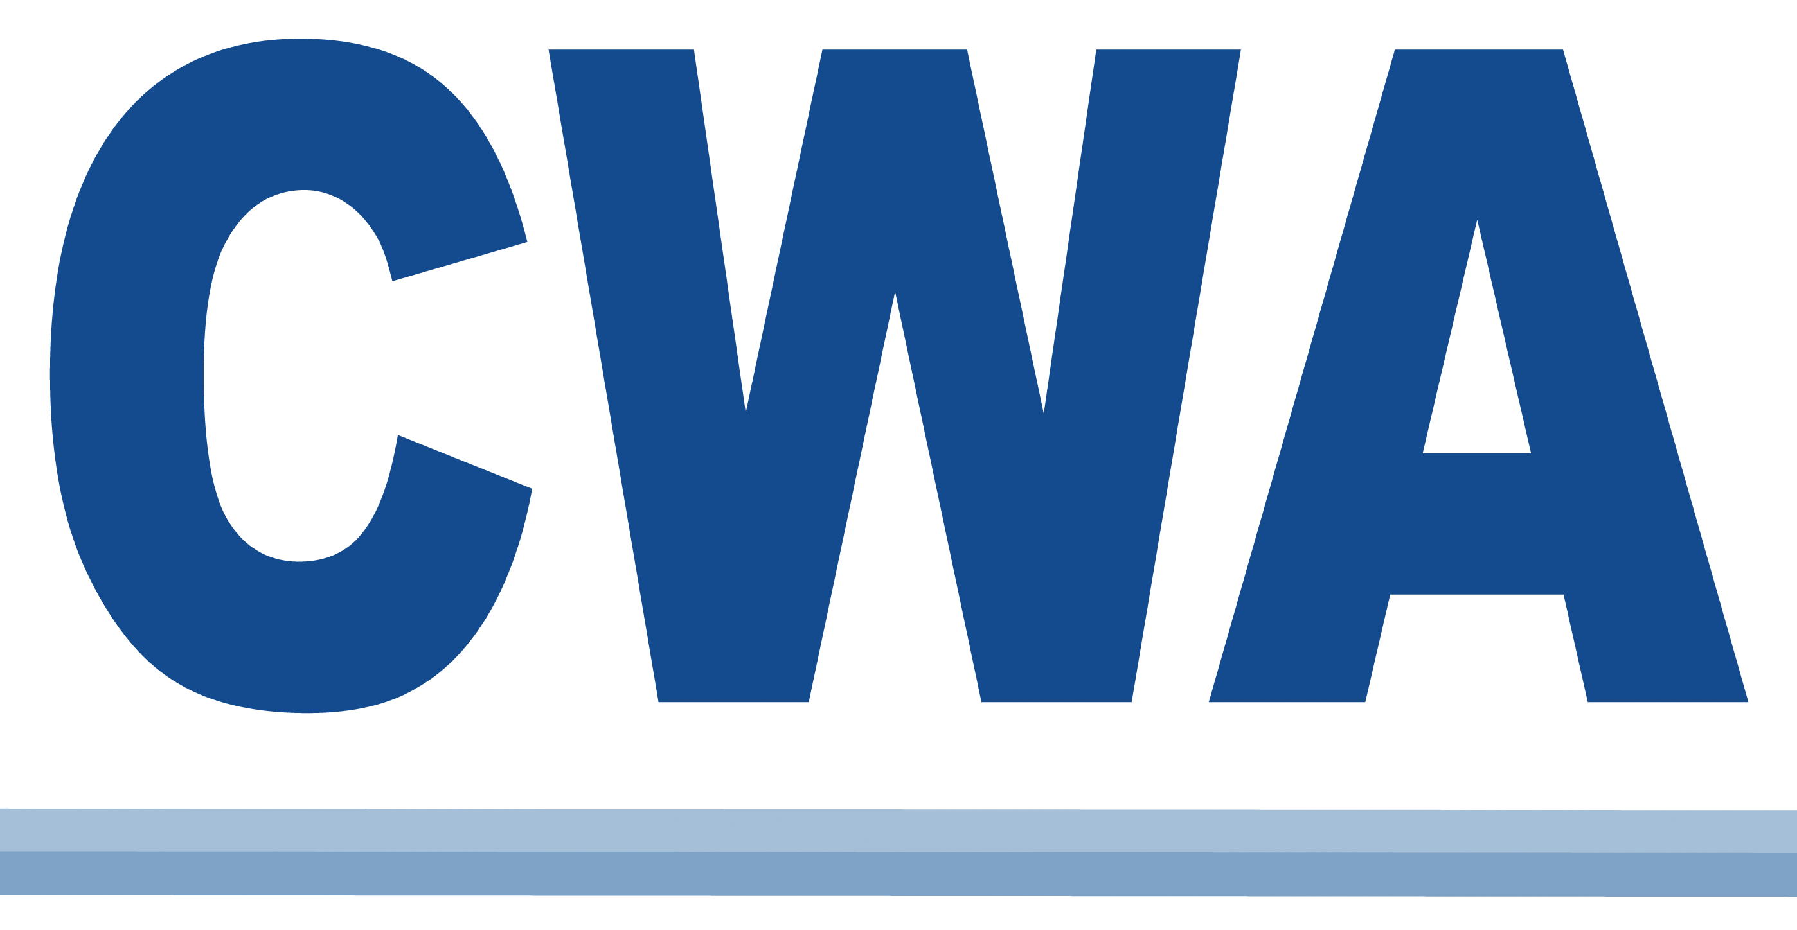 | CWA MEMBERS’ RELIEF FUND  STRIKER CERTIFICATION FORM

Local: 3105

Bargaining Unit: 0625401

NAME:

ADDRESS:

SOCIAL SECURITY #:

PHONE (Home):
(Cell):

E-Mail:

EMPLOYER: ATT / BellSouth Utility

WORKSITE:

STEWARD’S NAME:

I certify that I am eligible to receive strike benefits under the rules of the Members’ Relief Fund. I understand that if I am found ineligible under the rules, I will return any payments I am not entitled to.

_______________________________ ______________________________
Eligibility Verified Striker’s Signature

______________________________
Date
Original: CWA District Fund Agent
Copy: Local Union

DFR-1
(04/16)

