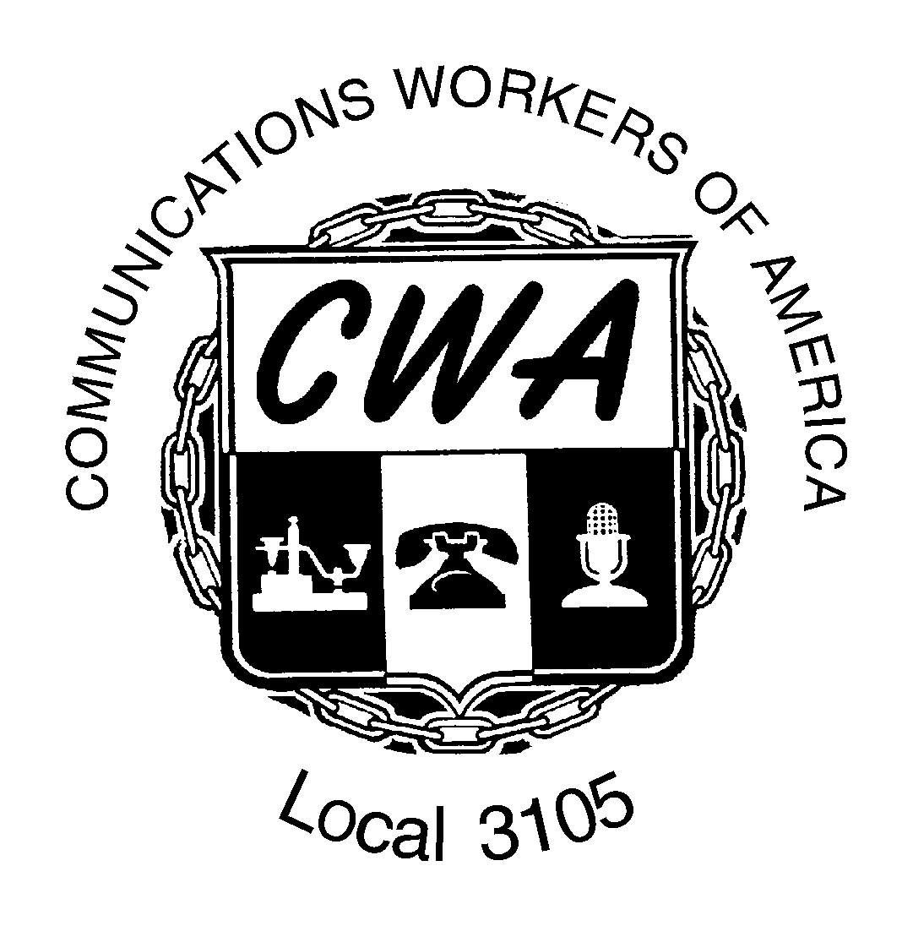
CWA Bargaining Survey For

National Bargaining Council

On October 7, CWA will convene the first National AT&T Bargaining Council in order to determine the union’s priorities for our next rounds of bargaining. The items selected will guide the bargainers at each of the regional bargaining tables. The Bargaining Council meeting is a direct result of changes to the CWA Constitution that our Local supported to improve our bargaining position and avoid conflicts with other districts over issues like health care, pension/retirement benefits, general wage increases, Prem Tech scope of work, etc. We need your input in setting our bargaining priorities.

Please fill out this questionnaire and return it no later than Friday, October 3, 2014.

Please mark each item below as to how important it is to you:
1 = Very important (would strike to achieve)
2 = Moderately important
3 = Not so important
4 = Not important at all

___ Wage Increase
___ Pension/Retirement Benefits Increase
___ Healthcare
___ Improved Vacations, Excused Work Days and Other Time Off
___ Job Security (ex: Subcontracting; Movement of Work; Technological Change)
___ Other Working Conditions (scope of work, scheduling, training, etc.) Please be as
specific as possible:
________________________________________________________________________________________________________________________________________________________________________________________________________________________________________________________________________________________________________________________________________________________________________________________________________________________________________________________________________________________________________________________________________________________________________________________________________________
Now circle your top priority!
(over)

CWA Constitution
Article XVII – Collective Bargaining
Section 3 – Bargaining Councils in Telecom
(a) The Convention or the Executive Board shall establish Bargaining Councils. Bargaining councils will formulate bargaining programs and agendas to apply to a single employer with bargaining units that cross District or Sector lines, associated employers or a number of employers, but limited to those agendas and programs affecting bargaining units represented on a bargaining council. The Executive Board shall be responsible for the development of bargaining programs for those units or groups for which bargaining councils have not been established.

(b) Bargaining councils shall comprise one representative from each local having members in bargaining units of the bargaining council, and they shall be certified to the President of the Union.

(c) The bargaining councils will designate certain issues as "National Issues." To be so designated, an issue must affect CWA-represented workers in multiple CWA Districts/Sectors.

(d) The bargaining resolution of a National Issue requires the agreement of all District/Sector Vice Presidents of CWA Districts/Sectors with at least one constituent local with a representative on the bargaining council.
Here’s how to contact me

Here’s How To Contact Me:

Name (required)________________________________________________________________
Personal Phone _______________________Work Phone__________________________
Work Location ______________________________Job Title _______________________
Personal e-mail: (not company mail)______________________________________________
Text – personal cell phone number ____________________________________________

Return completed survey to your Steward OR to by October 3, 2014:
Email: cwa3105@bellsouth.net
Fax: 352-377-3105

To be filled out by Union Members ONLY!

